

Educator Packet for A Day in the Life of the Hudson & Harbor
http://www.ldeo.columbia.edu/dayinthelife

The Packet is designed for educators & teachers with information on a range of data gathering activities that are a part of A Day in the Life of the Hudson and Harbor.
Please Note:
- Any combination of these activities can be completed as part of the day’s events.
- Additional activities are available on the Day in the Life website.
- STUDENT DATA RECORDING SHEETS are available on the website and should be used for recording data for the event. After recording we ask that all data be submitted within 24-48 hrs through an online data collection form that we will provide annually, along with photo scans of the student forms. In this packet we have included examples of data collection for each parameter outline in blue below.

PLEASE BE SURE TO RECORD TIME & UNITS OF MEASURE FOR EACH SAMPLING ITEM SO THAT COMPARISONS CAN BE MADE THROUGHOUT THE RIVER.

The topics covered here correspond with the Student Packets
ACTIVITY | PAGE
COVER PAGE: Site Information  - SURROUNDINGS DATA:  - Location, River Mile, Longitude & Latitude  - Physical Survey  - Sketch  - Boats & Ships  - PHYSICAL RIVER:  - Tides & Currents  - Weather & Wind  - CHEMISTRY of the RIVER:  - Water Temperature  - Salinity  - pH  - Alkalinity, Nitrates, Phosphates  - Dissolved Oxygen  - TURBIDITY  - SEDIMENT CORE  - FISH & MACROINVERTEBRATES  - Hudson River Watershed Fish Fauna Checklist  - JOURNALING & HUDSON RIVER ALMANAC | Page 1-4  Page 5-8  Page 9-11  Page 12  Page 13-14  Page 15-17  Page 18
COVER PAGE: SITE INFORMATION

Site information provides us with record of key information about who collected data from this site during this year (i.e. coordinator, organization, school, address, contact information, etc).
Teachers or educators can help the students complete this section.

ACTIVITY I- SURROUNDINGS DATA

Physical Survey: One of the many ways that the Hudson River is dynamic is from the ever changing and developing shoreline and even plant material in the water. A sampling site can change subtly or drastically from year to year. The physical characteristics of a site can influence the turbidity, chemistry, habitat function and biology that we find. We want to make sure that the data captures these changes so it is important for your students to take a step back and first observe their surroundings!

1. LOCATION, RIVER MILE, LATITUDE & LONGITUDE

The students’ data is a part of a large effort across 100 sites along the Hudson River and neighboring tributaries. Students should recognize the importance of recording the site information that is requested on the form as each is critical to the long-term value of the data:

- Location
  - Site name, City, County, State

- River mile
  - If you don’t know your river mile, you can use the Hudson River Estuary Map (page 2) to help identify a general location. Note that when we post the data we will use the RM we have assigned it from our database of overall sites.

- GPS Latitude & Longitude
  - We use the latitude and longitude for site location. This can be obtained from a GPS, or a compass app on a smart phone (location must be enable) or Google Maps/Maps on a smart phone.
  - This is also an educational activity for the students to help them to develop geospatial skills through connecting these numbers to a location on a map.
    - First: Use the latitude and longitude from the step above.
    - Second: Use a river map with latitude and longitudinal markings along the edges, this can be a navigational charts or this simple river map can be printed and taped together into one long map for used. In this activity students locate the latitude and longitude along the edge of the map and draw perpendicular lines (actual or imaginary) to connect the two locations. This should match where you are!
2. AREA
In one sentence, the students are to describe their area so someone could find their sampling site. Be specific! Students should specify:
- Their location in relation to a significant landmark (i.e. bridge or pier)
- Whether they are sampling within a cove, on the beach, off the pier, etc.
- How is this site used by people? Do people come for picnics, launching boats, fishing, swimming, or other activities?

3. SAMPLING SITE
Make observations about your sampling site. Ensure that your students check all that apply.

- Is there a pier?
- Is it forested?
- Is it open and grassy?
- Is there a parking lot?
- Is there a piping entering the water
- Are the banks altered?
- Is it lined with bulkhead- seawalls, wooden timbers, or metal plates to hold the shore in place
- RipRap- a line of large rocks piled up on shore

All of these features can impact the data that you collect. Teachers can lead a discussion with their students about how each one of these features could impact their data.

4. SURROUNDING LAND USE
Make observations about the surrounding land use. How the neighboring land is being utilized can also impact the data you collect. When deciding the size of the area to include you should consider what you can see in the area around you.
Record the surrounding land uses as a percentage of 100%. For example, 50% is half the usage.

- % Urban/Residential
- % Forested
- % Beach
- % Industrial/Commercial
- % Other (specify)

5. SHORELINE
Describe the shoreline sediment:
Record the shoreline as a percentage of 100%. For example, 50% is half usage.
- Sandy
- Muddy
- Rocky
Note: Other descriptions of the shoreline alterations should be included in the Sampling Site description.

6. RIVER BOTTOM
Describe the water area itself and the composition of the bottom of the river. The water area and bottom type can influence the different biological species that we find.
Students should record:
- The estimated Water Depth (cm)
- Check all that apply:

  - Bottom muddy
  - Bottom sandy
  - Bottom weedy
  - Bottom rocky

7. WATER
The wind speed can impact the physical and chemical conditions of the water. On the surface of the water, observe whether the water is Calm or Choppy.

8. PLANTS IN WATER
Aquatic and submerged aquatic vegetation provide fish habitat, filter out sediments and nutrients, and can assist with oxygen exchange in the water. Some species, like water celery, add dissolved oxygen to the water. Other species, like water chestnuts, can create an oxygen-depleted zone. Some plants are native, while others are non-native or invasive. In the freshwater section of the river you can use the Hudson River Field Guide to Plants of Freshwater Tidal Wetlands to identify plants found growing in the water.

Record the aquatic plants species as a percentage of the total area covered. For example, if water chestnuts covered half of the site, it would be 50%. If NONE, please check “No plants in water area.” Below is a list of aquatic and submerge vegetation that you may see at your site:

Tidal Shallows
Eurasian Water Milfoil | Water Chestnut | Water Celery | Other (Specify)
Tidal Marshes
Arrow Arum | Arrowhead | Big Cordgrass | Broad Leaved Cattail
Bur-Reed | Golden Club | Jewelweed | Mud Wort
Narrow-leaved Cattail | Pickerelweed | Phragmites/Common Reed | Purple Loosestrife
Reed Grass | Saltwater Cordgrass | Spatterdock | Swamp Rose-Mallow
Sweet Flag | Wildrice | Yellow Flag | Yellow Pond Lily
Other (Specify)

9. Sketch the Sample Site:
Students will sketch a map of your sampling site. Include a compass rose (N, S, E, W) and rough scale. Label landmarks or notable features. Indicate specific locations where you sampled. If available, use a digital camera to photograph your site.

Example:
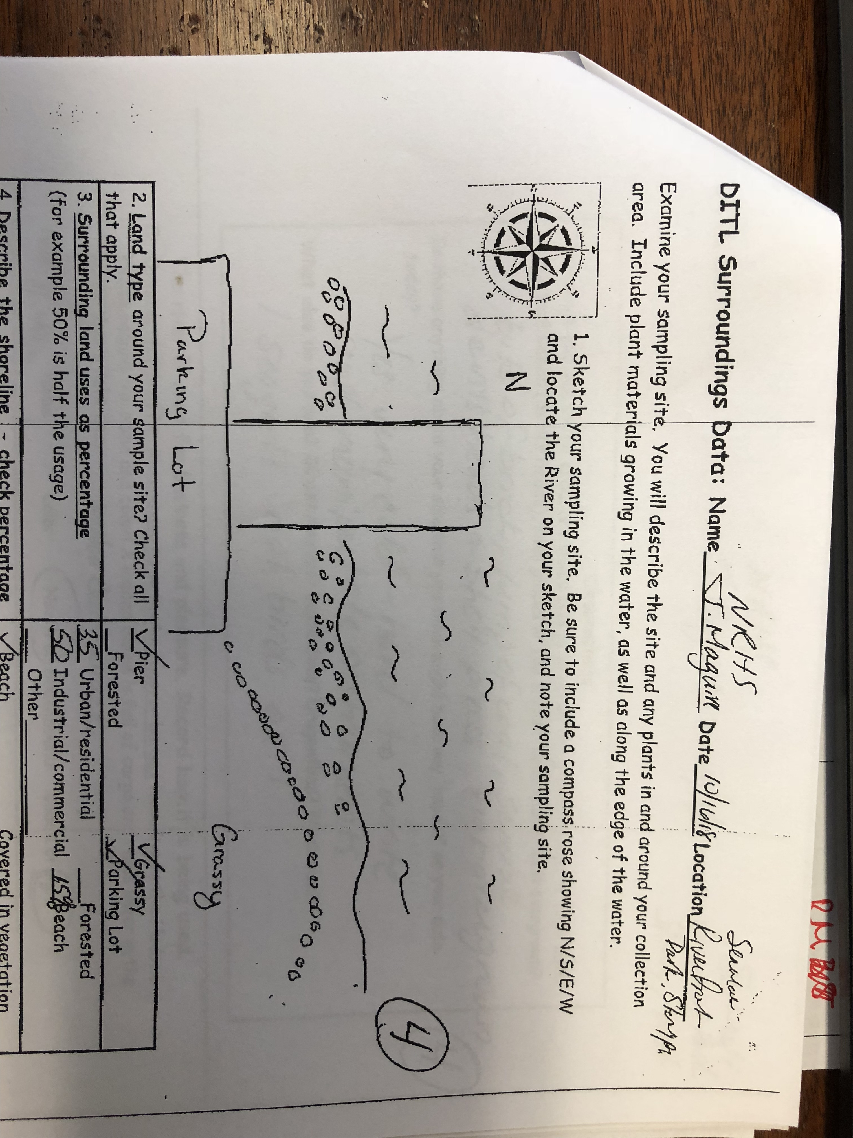

10. Boats and Ships:
The Hudson River is an industrious river, often being used for business and pleasure. You may see boats and large ships, tugs, or barges pass by your site. We are mainly interested in commercial shipping to show the working river and exhibit how the river is being used (i.e. large boats, tugs, or barges). If recreation use dominates the river, we should note this as well (i.e. sailboats, kayaks, speed boats).

Shipping Details: Record the time, name of the vessel, color, direction (North or South), and whether it is loaded or light. A loaded ship or barge is full of cargo, and rides lower in the water than a light, empty vessel. Binoculars are helpful in gathering the information requested here. If details on this are collected it is possible to track a ship’s movement up or down river and even calculate its transit speed!

ACTIVITY II – PHYSICAL RIVER

1. TIDES:
- Tides are the rise and fall of the water level in large bodies of water that are caused by the combined effects of the gravitational forces exerted by the Moon and Sun, and the rotation of the Earth. Through its connection to the Atlantic Ocean the estuary section of the Hudson River experiences semi-diurnal tides or two nearly equal high and low tides a day. Therefore, every 6 hours, the tides will shift. On a flooding tide, salty water from the Atlantic Ocean is pushed into Hudson, causing the water to rise and bringing the leading edge of the salt further North. On an ebbing tide, water is pulled back toward the ocean, lowering the tide and moving the leading edge of the salt South.
- Tidal range is the vertical different in height between the high tide and low tide, which varies depending on where you are in the river and is controlled by the river width. Much of the central section of the river experiences a tidal range ~ 3ft, while at the Troy dam the tidal range is close to 5 ft. The vertical tidal range can also vary with different stages of the moon. During a full moon, when the Earth is between the sun and the moon, and the new moon, when the moon is between the sun and the Earth, the sun and moon alignment increases the gravitational pull. This strong gravitational pull causes very high and very low tides resulting spring tides, or a large tidal range. During the moon’s quarter phases, the gravitational pulls cancel out, and the tidal ranges are at their lowest known as neap tides.

Method 1: Tide Stick Method
- Firmly set a dowel marked in 10cm increments into the river bottom sediment in the water & leave it.
- Once set the students record where the water level is on the stick as the “Start Time-Water Height (cm)”
- Students check the tide stick every 15-30 minutes to record the water height on the dowel and the corresponding time. Students can observe (or even calculate) how quickly the tide changes throughout the day.
- As the tide rises (flood tide), the measurements on the tide stick will be increasing as the water moves up the stick. As the tide falls (ebb tide), the measurements will get smaller.
- Be sure you talk this through with your students so you are sure they understand so they correctly record whether the tide is ebbing, flooding, or still/slack tide, when the tide is transitioning and no change in measurement is recorded.

Method 2: Pier/Dock to Water
- The goal is to measure from the dock to the surface of the water. Tape measures (cm) are fairly light-weight so this might need to be done with a weighted line that is then measured with a tape.
- Mark your location on the dock so measurements are collected from the same place each time.
- Students remeasure every 15-30 minutes and record the distance between the dock and the surface of the water and the corresponding time. Students can observe (or even calculate) how quickly the tide changes throughout the day.
- Since you are measuring the dock to the surface of the water, as the tide rises (flood tide), the measurements will get smaller. As the tide falls (ebb tide), the measurements will get larger.
- Be sure you talk this through with your students so you are sure they understand so they correctly record whether the tide is ebbing, flooding, or still/slack tide, when the tide is transitioning and no change in measurement is recorded.

Simple Method:
- At a beach- Use slender strong sticks as tide markers. At the start, place one stick at the water’s edge. Push it deep into the ground or pile rocks at its base to hold it in place. Every 15 or 30 minutes check your marker. If the level has changed, place the second stick to mark the new position of the water’s edge on a beach so through time you see the total change. Record on your sheet the time and whether the water level was flooding, ebbing, or still.
- Pier or bulkhead- Choose a distinct, immoveable feature on or near the bulkhead to see whether the water level is rising or falling. If there are waves, use your judgment in deciding where the water’s edge/surface is. Record on your sheet the time and your observations. After several observations record whether the water level was flooding, ebbing, or still.

**Extra Activity:
If your students have time at this station, they can calculate how quickly the tide is rising or falling by dividing the change in height by the time between recordings. Think of the basic definition of speed as distance divided by time (D)/T.
Calculation:
- Subtract a time from prior reading from the time of this reading for ‘time of travel’ (or time elapsed).
- Calculate the change in height by subtracting the water height from the prior reading from the water height from this reading for the ‘distance traveled’.
- Divide the change in height by the time elapsed. This is the rate (speed) of tidal change.
(Water Height (cm) – Start Height (cm))/ (Checked Time – Start Time)= Speed of Tidal Change (cm/min)

2. CURRENTS
Currents are the internal movement in the water sometimes described as a push and pull in the water. The Hudson River is known as the ‘river that flows both ways’ because it’s currents are driven by the rising and falling of tides, mimicking the tide’s ~6 hour cycle. However, extreme weather, such as excessive rains or strong winds, can impact the currents by overwhelming or suppressing them.
- BE CAREFUL! The tidal current does not always coincide with the wind blown surface water. While the water may look as if it is flowing in one direction, the current’s direction may surprise you!
- NOTE: Make notes of any features about the site, river or shoreline that may cause the current near shore to flow in a different direction than the current out in the middle of the Hudson (a protected embayment, a pier jutting out causing an unusual swirling)?
- DATA FROM THE MAIN CHANNEL IS THE BEST DATA TO RECORD SO PLEASE BE ALERT TO DIFFERENCES THAT MIGHT EXIST AND MAKE A NOTE.

Method 1: Orange Toss
- This is a great teamwork activity! This measurement requires full participation from 5 students.
- Record the time that you start collecting current data. Remember currents vary throughout the day!
- Make a Prediction- what way do students predict the current is moving?
- Measure 10m and lay out the tape measure on the ground.
- Student #1 and #2 should be position at 0m and 10m (i.e. at start and end of the measuring tape). Have them hold up a clipboard or binder to block their vision from the orange being tossed in the middle of the measuring tape. Additionally it helps to close the eye furthest from the clipboard so they can only see straight ahead.
- Student #3 will toss an orange at the 5m marker (middle) as far as they can, trying to reach the main current of the river.
  - An orange is used to measure the speed of the current because oranges have the perfect buoyancy to float and still be heavy enough to rest in the tidally driven current, not the wind driven surface waves. A large solid stick that is large enough so the wind can’t push it can work as well.
- When the orange hits the water, it will submerge and then pop back to the surface. The moment that the orange resurfaces, Student #4 should start the stopwatch.
- Often the orange is not thrown straight so Student #5 should mark the starting point of the orange if it is not perfectly aligned with the middle of the tape measure (5m).
- Once the orange is parallel to one end of the tape measure (either 0m or 10m depending on whether it is flowing north or south), either Student #1 or #2 will yell “STOP” when they see the orange come into their sight while still holding the “blinder”.
- Student #4 will immediately stop the stopwatch.
- Calculate & Record:
  - Record the time that your team started collecting current data
  - Measure the distance travelled by the orange using the starting position of where the range entered the water (Student #5) to the end of the distance traveled. We will work in cms.
  - Record the amount of time in seconds that it took the orange to travel the measured distance
  - Calculate the current speed by dividing the distance by time (cm/sec).
  - If the current is Ebbing (outgoing/south), Flooding (incoming/north), or Still
  - Record any Metadata or observations about your site that could influence the currents.
Method 2: Simple Method
Every student rotation or every hour toss an orange (or stick) as far out into the water as you can. Record the time and direction of travel as Flooding (North towards Albany), Ebbing (South towards the Atlantic), or still (slack tide is in between the high and low tide).

Extra Activity: Calculate KNOTS: If your students want to calculate the rate of travel in knots use the distance in cm for 60 seconds to compute this. Let’s think this through:
1 kt. = 6076 ft. per hr. Convert ft. to cm. 1 ft. = 30.48 cm. so multiple these two to compute cm/hr or 185196.5 cm/hr. Now divide by 60 for cm per minute (3086.6 cm/min.) now by 60 again for cm/sec. What you find is that: 1 kt =51.44 cm/sec.
SO to compute Knots from cm/sec use the following equation:
Knots= (cm/sec)/51.4
Example: If the orange travelled 63 cms in 30 seconds divide 63/30 = 2 cm sec. /51.4 = .04 kts.

WEATHER AND WIND:
Weather and wind are important pieces of physical data that help to provide context for the other data. Weather includes current conditions and conditions over the last few days that may have an impact on the data you collect today (such as rain, extremely hot or cold temperature). Wind levels can increase choppiness in the water thus adding oxygen and increasing levels of oxygen saturation. Wind can also affect movement on the top of the water surface making it difficult to assess currents.

- AIR TEMPERATURE
Conversions: ◦C = 0.556 X (◦F - 32◦ )
◦F = (1.8 X ◦C ) + 32◦
Record conditions at the start of sampling. Record changes every hour if possible.
Time_10:30AM Air temperature 56 º F 13.3 º C
Time 11:30 PM Air temperature 59 º F 15 º C

- WIND SPEED
(PLEASE REFER TO BEAUFORT CHART BELOW)
Using the Beaufort chart record the FIRST COLUMN as Beaufort FORCE 3 .
Using an anemometer, record wind speed: 8 kts (preferred) and/or ________mph
Record wind direction (direction the wind is coming/blowing from): Northeast
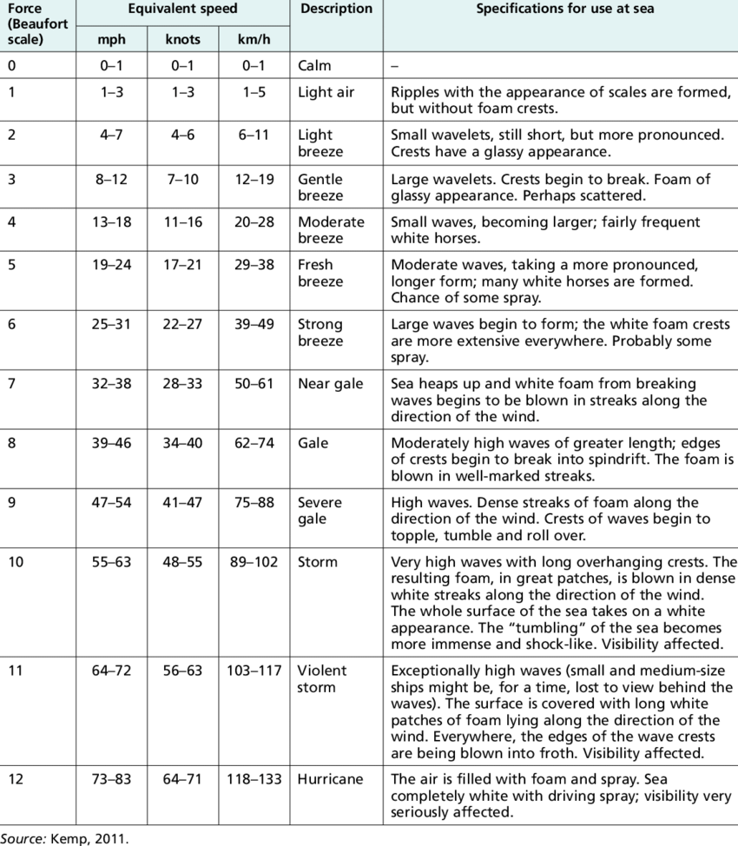

- CLOUD COVER

Cloud cover (check one) clear_______ partly cloudy___ mostly cloudy: X overcast___

- RAIN (PRECIPITATION) TODAY & WEATHER FOR THE PAST 3 DAYS

Recent weather (especially rain) can also play an important role in the status of the Hudson River. For example, if we had a large rain storm, it could take days for all the freshwater from the neighboring tributaries to drain into the Hudson River. This ultimately drives the salinity down days after the rain event.

Time: 12:00 PM Precipitation? NO How much? __________

If the weather changes over the time you are sampling, please note that here.
The weather became more windy throughout the day.

Briefly describe the weather for the last 3 days. Any rain, wind, or unusual temperatures?
It rain about 3 inches in the past 3 days, and the weather was chilly and windy

ACTIVITY III- CHEMISTRY of the RIVER

1. WATER TEMPERATURE
Water temperature is important for understanding the amount of dissolved oxygen the water can hold, and for the fish communities in the area. Students will better understand Fahrenheit temperatures, but in science it is important to become familiar with Celsius. If possible, record water temperature in BOTH degrees Celsius and degrees Fahrenheit to help them develop a connection between the two. If you don’t have both ºC and ºF thermometers, students can convert between the two using the following formulas:

ºC = 0.556 x ( ºF - 32) ºF = (1.8 x ºC) + 32

It is best to take the water temperature several times in succession and then average. Over the day, you will want to check for change, especially in shallow water and backwater areas, which may show more variation through the day due to sunlight, tide or current changes.

Time Reading 1 Reading 2 Reading 3 Average
10:30AM ºF 56 56 58 56.67 F
ºC 13.333 13.333 14.444 13.70 C

2. SALINITY
Different instruments measure salinity as ‘total salts’, or ‘chloride’ (a fraction of total salts) or even conductivity. Therefore, it is essential that you mark down what instrument you use to measure the salinity. Marine and Brackish sections we use hydrometers, refractometers or meters in ppt or ppm. Freshwater sections of the river, the units of measurement may be parts per million (ppm). The quantabs measure ppm Cl- and not total salinity so please record them that way.

How do we determine salinity in the Hudson
Freshwater <100 ppm | Brackish water 100-18,000 ppm | Marine >18,000-35,000 ppm

In saltier parts of the estuary, you may also see measurements expressed in ‘parts per thousand’ (ppt); one part per thousand equals 1000 mg/l. In the fresher parts of the estuary background levels are measured using quantabs as Cl – a part of total salinity.

BE SURE TO MARK THE EQUIPMENT YOU ARE USING FOR THE TEST:
Quantab Strips (PPM Cl⁻): High Range X Low Range
Record PPM CHLORIDE (3rd column on Quantab bottle)
Meter/Probe
(PPT)

Refractometer
(PPT)

Hydrometer
(PPT)

Repeat several times in succession and average the results. UNITS, UNITS, UNITS! ☺

Time Reading 1 Reading 2 Reading 3 Average Units
10:30 AM 848 ppm Cl- 779 ppm Cl- 848 ppm Cl- 825 ppm Cl-

(If reading conductivity please record with appropriate unit uS/cm (microsiemens) or mS/cm (milliseimens and then convert to salinity if you have that ability)

3. pH (POTENTIAL HYDROGEN)
A measure of the acidity of an area. pH has no units listed with it. Neutral is 7, acidic is < 7, basic is >7. Repeat several times in succession and average the results.

BE SURE TO MARK THE EQUIPMENT YOU ARE USING FOR THE TEST:
Test Strips____

Color Match Test Kit X
01
Meter____

pH Pen____

Time Reading 1 Reading 2 Reading 3 Average
10:30 AM 7.5 7.6 8.0 7.7

ADDITIONAL CHEMICAL TESTS IF DESIRED: 4. Alkalinity, 5. Nitrates, and 6. Phosphates
The following tests typically require more complex methods than those described above. There is no requirement to do these, but if you have the equipment and ability, the data would be welcome

4. ALKALINITY
Alkalinity is a measure of water’s ability to neutralize (buffer) acids, such as those that might be found in acid precipitation. Don’t confuse it with pH. pH measures how strongly acidic or alkaline the water is; the alkalinity test determines the concentration of alkaline compounds in the water – or water hardness. In pure water, small amounts of acid or alkaline substances will cause dramatic shifts in pH – however with the addition of small particles of water hardness substances in the system causes a buffering that absorbs or soaks up small changes to the system. The expected range of alkalinity in the Hudson is between 80-100 mg/L of calcium carbonate (CaCO₃).

Repeat several times in succession and average the results.

Time Reading 1 Reading 2 Reading 3 Average

11:30 am 80 93 85 86 CaCO₃ mg/l

5. NITRATES
Nitrate (NO₃⁻ ) is a nutrient used by plants and animals for growth and maintenance. It is relatively plentiful in freshwater ecosystems but less so in saltwater ecosystems, where it is typically the limiting nutrient. The expected range of nitrates in the Hudson River is low (<1-2 mg/L).
If you are measuring with an LaMotte Estuary Wide Sampling kit, you will NOT get an accurate measurement because the range is not high resolution. PLEASE NOTE IF YOU USED THIS KIT.

Repeat several times in succession and average the results.

Time Reading 1 Reading 2 Reading 3 Average

11:30 am 1 0.8 0.85 0.8833 NO₃⁻(mg/l)

6. PHOSPHATES
Phosphate (PO₄⁻³) enters the water through release by some rocks, soil, and animal waste and serves as a nutrient for plants. It is usually the nutrient least available in freshwater ecosystems. The expected range of phosphates in the Hudson River is low (<1 mg/L). If you are measuring phosphates with an LaMotte Estuary Wide Sampling kit, you will NOT get an accurate measurement because the range is not high resolution. PLEASE NOTE IF YOU USED THIS KIT.

Repeat several times in succession and average the results.

Time Reading 1 Reading 2 Reading 3 Average

11:30 am 1 0.9 0.83 0.91 PO₄⁻³ mg/l

7. DISSOLVED OXYGEN (D.O.)
The amount of dissolved oxygen (DO) in a river is one of the most important factors determining its health. Many variables influence DO, including temperature, time of day, presence of plants, and wind conditions. DO measurements are given in mg/l and as percent saturation. At 100% saturation, water of a given temperature cannot hold more DO. If more is added - by wind or turbulence, saturation may temporarily exceed 100%. In this case oxygen will diffuse from the water into the air. Saturation levels below 100% are not necessarily the result of pollution. At night, when plants aren’t producing oxygen through photosynthesis, saturation may fall below 100% as living things use up the available DO.

BE SURE TO MARK THE EQUIPMENT YOU ARE USING FOR THE TEST
Meter/Probe

Drop Count Kit X

Other

Time Temperature in ºC DO (mg/l) % saturation
10:00 AM 16 ºC 7 mg/l (or ppm) 70%

DETERMINING PERCENT SATURATION THE "QUICK AND EASY" METHOD
Source of chart: http://waterontheweb.org/under/waterquality/oxygen.html
For a quick and easy determination of the percent saturation value for dissolved oxygen at a given temperature, use the saturation chart. Pair up the mg/l of dissolved oxygen you measured and the temperature of the water in degrees C. Draw a straight line between the water temperature and the mg/l of dissolved oxygen. The percent saturation is the value where the line intercepts the saturation scale. Waterways with a saturation value of 90% or above are considered healthy.

ACTIVITY IV: TURBIDITY

Turbidity is water clarity, an important feature of an estuary. In the Hudson River, turbidity is made up of small bits of plankton, pieces of detritus or decomposing plant and animal matter, salt and suspended bits of sediment. Different techniques for determining turbidity use different units of measurement. Be sure to enter data on the correct line for the technique you use. Repeat several times in succession and average the results.

Be careful! If you are collecting water for a site tube, DO NOT to step in the water as you collect it or you will add turbidity to your sample.

Time Reading 1 Reading 2 Reading 3 Average

secchi disk ______ ________ ________ ________ ________ feet or cm
short sight tube ______ ________ ________ ________ ________ JTUs
long sight tube 11:00 AM 11.6 cm 12.04 cm 13.10 cm 12.25 cm cm/meters
turbidimeter ______ ________ ________ ________ ________ NTUs

The order of equipment preference is as follows:
1. Long sight tube, 2. Secchi disk, 3. Short sight tube, 4. Turbidimeter.
Observations
How turbid to you think your water is? How would you describe it in words?

I think the water is very turbid because it is not very clear.

I would describe the water as brown, turbid, and murky.

ACTIVITY V – SEDIMENT SAMPLING
*Use the Step-By-Step directions sheet provided online on the resources page
http://www.ldeo.columbia.edu/edu/k12/snapshotday/Resources.html

BACKGROUND INFORMATION:
- The sediments in the core represent a period of time. The material at the bottom is older than the material on the top. This is an important principle of geology and much of Earth Science called ‘superposition’.
- If material has been accumulating steadily, a sediment core will contain a record of the material transported by the river through time.
- One of the challenges faced by scientists who study sediment cores is determining the length of time represented by the sediments core. You can not tell how many years your core represents by simply looking at it. The amount of time represented by your core will vary depending on the specific place and processes of the river in each area. In sections with high deposition, it could represent a very short amount of time (days to a year), while in other areas it could represent a much longer time (10s to 100s of years or longer).
- What you can tell from looking at a core is whether the color changes over the length of the core. You will note the color of the sediments at the very top of the core. If the color is light brown, this is an indication that the surface sediments are oxidized (in contact with oxygen in the water). The oxidized section is the top represents an unconsolidated recent deposition. You will measure this and record it to determine how active the deposition is in your area. Usually, the sediments change to a darker color below the oxidized layer, this is called anoxic (no oxygen) or reducing. It usually means that these sediments have been out of contact with the oxygen in the river water and are older. Often this section will have a sulfur smell noting bacterial decomposition. Extrude your core, then measure and record each section. Complete the core assessment sheet as you observe and describe it. Note anything else that you think is significant. Are there other visible layers? Color changes? Coarse sands and small pebbles collect in areas of fast moving water, fine sands and silts collect in calm and slow water.

- X-Ray Fluorescence (XRF) Spectrometer– What does this mean? Once you collect your core and describe it you will be sending one to Lamont for X-Ray Fluorescence. This is done with a piece of equipment that can measure lead and other metal concentrations in the sediments. We focus on lead since it can be used as an indicator of time. There is a natural background reading of lead in the river (approx. 20ppm) but human (anthropogenic) influences such as early 20th century industry, leaded gas etc. have caused in increase in that level. Using the XRF we can look at what the readings of various metals are in different areas of the river. At Lamont we hope is to use this information to roughly constrain (locate the probably range) the age of sediments you collect. A straightforward interpretation of this data is that low levels of lead similar to natural background would indicate sediments that are older than (deposited prior to) approximately 1900, while sediments containing lead a levels elevated above the natural background would indicate sediments that are younger or deposited as part of industrialization.

SEDIMENT SAMPLING:
Push cores are distributed to participating sites where coring is possible. If you don’t have a corer you can skip this activity. Prior to sampling (i.e., before the bag gets wet), please use a permanent marker and label bag with the following information:
- Date – River Site –River Mile
- Example:
- 100809_PP_25 (for Piermont Pier)

- You will be taking a core to examine and describe with your group using the form on the next page. Once the description is complete scoop the pieces into a Ziploc bag and return it to Lamont-Doherty Earth Observatory for X-Ray Fluorescence analysis (this will be picked up). The core will be homogenized for sampling so do not worry about squishing the sample.

DISCUSSION:
Once you have the core for group analysis use the sheet that is in your protocols to look through and analyze it with the group. Discuss how any unusual items might have ended up in the river and the role they play there.

NOTE: if the area you are coring is primarily sand, the corer may not work and the sand may fall out when you lift the corer from the water. In this case, if you would still like to examine the bottom of the river with your students you might be able to slide a flat piece of something under the base of the corer and still extract a sample to look at. If that isn’t possible, consider using a jar to scoop out a section trying to obtain a sample that goes down 3-4 inches. The same activities can be completed with this type of sample. When you bag your sample please note it was not obtained with the corer.

ACTIVITY VI – FISH & MACROINVERTEBRATES

The data section below is set up for fish and invertebrates such as crabs and crayfish that are easily visible without magnification. This sheet can be adapted if you plan to capture and study plankton. If making repeated collections, record data for each haul and then add the catch totals together. If you have trouble identifying organisms to the species level, list them at the most specific level of classification possible. TAKE PICTURES and submit those to us! Young of the year herring - alewife, blue-back herring, and American shad - look very similar to one another, as do very young sunfish. Group them together as herring or sunfish. Measure the largest individual of each species. It will not be possible to tell males from females for most of what you catch, but for a few - blue crabs for instance - it is possible and very useful to distinguish gender.

So that we can compare data from site to site please list:
Length of SEINE NET 50 ft Length of SEINE PULL 7 yards Total # of FISH PER HAUL 27
Total number of seines or catches you ran during your study period 1
If you site used traps, please note catches per trap:
If you use oyster cages please note this
If your site was visited by the fisheries team please note what fish came from this group

FISH SPECIES: Use separate sheet for each seine OR note what was caught in each seine by noting seine #.
TIME: 12:30 pm LENGTH OF NET: 50 feet
METHOD: Seine: X.Traps: Rod & Reel: Electro-Shocking: Trawl: Dip net: Other: (Explain)
Fish Species: # of individuals: Size of largest (unit)
1. Striped Bass 5 5 inches
2. White Perch 2 6 inches
3. Atlantic Silverside 20 3 inches
4. ____________________________ ____________ ___________ ____
5. ____________________________ ____________ ___________ ____
6. ____________________________ ____________ ___________ ____
7. ____________________________ ____________ ___________ ____
8. ____________________________ ____________ ___________ ____

MACROINVERTEBRATES: For crabs please note type (blue, mud, Asian etc.) and sex (M/F)
COLLECTION METHOD: Seine X. Kick Net Trap Eel Mop Other (Explain) __________________
1. Blue Crab # 15 Notes: all males
2. Green Crab # 2
3. Shore Shrimp # 30
4. ____________________________ ________
5. ____________________________ ________
To Compute Catch Per Unit Equivalent (CPUE) – Let’s use a 50 ft. net for the example. Take length of net (50 ft.) X length of pull (example: 7 yards X 3 ft = 21 ft.). Convert to inches: 50 ft. X 21ft X 12 (for inches per foot) = total inches. Convert to meters: divide by 39.37 (for inches in a meter) = 320 meters. Then divide your catch by 320 to get catch per meter seined. This figure should be computed for each seine event.
If you pull the net in just to close a circle the formula is: Net Length (ft.) ___X 12 = total inches / 39.37 (inches in a meter) =_____ Then divide your catch by this number for your CPUE.

Seine # 1 Time 12:30 pm Catch Total 27 Length of Pull 21 ft Computed CPUE: 0.084

Hudson River Watershed Fish Fauna Check List

1 _____ lamprey, silver
2 _____ lamprey, American brook (n)
3 _____ lamprey, sea (n)
4 _____ shark (dusky shark?) (n)
5 _____ hammerhead, smooth (n)
6 _____ dogfish, smooth (n)
7 _____ dogfish, spiny (n)
8 _____ skate, little (n)
9 _____ skate, barndoor (n)
10 _____ stingray, bluntnose (n)
11 _____ ray, cownose
12 ____ sturgeon, shortnose (n)
13 ____ sturgeon, lake (n)
14 ____ sturgeon, Atlantic (n)
15 ____ gar, alligator
16 ____ gar, longnose
17 ____ bowfin
18 ____ ladyfish (n)
19 ____ tarpon
20 ____ bonefish (n)
21 ____ eel, American (n)
22 ____ worm eel, speckled (n)
23 ____ eel, conger (n)
24 ____ herring, blueback (n)
25 ____ shad, hickory (n)
26 ____ alewife (n)
27 ____ shad, American (n)
28 ____ menhaden, Atlantic (n)
29 ____ herring, Atlantic (n)
30 ____ shad, gizzard
31 ____ herring, round (n)
32 ____ thread herring, Atlantic (n)
33 ____ anchovy, striped (n)
34 ____ anchovy, bay (n)
35 ____ stoneroller, central
36 ____ goldfish
37 ____ dace, redside
38 ____ chub, lake (n)
39 ____ carp, grass
40 ____ shiner, satinfin (n)
41 ____ shiner, spotfin
42 ____ carp, common
carp, mirror (var.)
43 ____ Amur carp (var. koi)
44 ____ minnow, cutlip (n)
45 ____ minnow, brassy (n)
46 ____ minnow, eastern silvery (n)
47 ____ shiner, bridle (n)
48 ____ shiner, ironcolor (n)
49____ shiner, common (n)
50____ dace, pearl (n)
51 ____ chub, hornyhead
52 ____ shiner, golden (n)
53 ____ shiner, comely (n)
54 ____ shiner, emerald
55 ____ shiner, blackchin
56 ____ shiner, blacknose
57 ____ shiner, spottail (n)
58 ____ shiner, rosyface
59____ shiner, sand
60 ____ dace, northern redbelly (n)
61 ____ dace, finescale (n)
62 ____ minnow, bluntnose
63 ____ minnow, fathead
64 ____ dace, eastern blacknose (n)
65 ____ dace, longnose (n)
66 ____ chub, creek (n)
67 _____ fallfish (n)
68 ____ bitterling
69 ____ rudd
70 _____ sucker, longnose (n)
71 _____ sucker, white (n)
72 _____ sucker, summer (n)
73 _____ chubsucker, creek (n)
74 _____ hog sucker, northern (n)
_____ buffalo hybrid (black x smallmouth)
75 _____ redhorse, shorthead
76 _____ weatherfish, Oriental
77 _____ pirapitinga (red-bellied pacu)
78 _____ catfish, white (n)
79 _____ bullhead, yellow (n)
80 _____ bullhead, brown (n)
81 _____ catfish, channel
82 _____ stonecat
83 _____ madtom, tadpole (n)
84 _____ madtom, margined (n)
85 _____ madtom, brindled
86_____ pickerel, redfin (n)
87_____ pike, northern (n)
muskellunge, tiger (norlunge)
88 _____ pickerel, chain (n)
89 _____ mudminnow, central
90 _____ mudminnow, eastern (n)
91 ____ smelt, rainbow (n)
92 _____ herring, lake (cisco) (n)
93_____ whitefish, lake (n)
94_____ trout, rainbow
95 _____ kokanee (sockeye)
96 _____ salmon, chinook
97 _____ whitefish, round (n)
98 _____ salmon, Atlantic (n)
99 _____ trout, brown
100 _____ trout, brook (n)
_____ trout, tiger (brown x brook trout)
101 _____ trout, lake (n)
102 _____ lizardfish, inshore (n)
103 _____ trout-perch (n)
104 _____ rockling, fourbeard (n)
105 _____ cod, Atlantic (n)
106 _____ tomcod, Atlantic (n)
107 _____ pollock (n)
108 _____ hake, silver (whiting) (n)
109 _____ hake, red (ling) (n)
110 _____ hake, spotted (n)
111 _____ hake, white (n)
112 _____ cusk-eel, striped (n)
113 _____ toadfish, oyster (n)
114 _____ goosefish (anglerfish) (n)
115_____ needlefish, Atlantic (n)
116 _____ houndfish (n)
117 _____ minnow, sheepshead
118 _____ killifish, eastern banded (n)
119 _____ mummichog (n)
120 _____ killifish, striped (n)
121 _____ killifish, spotfin (n)
122 _____ mosquitofish, western
123 _____ silverside, brook

124 _____ silverside, rough (n)
125 _____ silverside, inland (n)
126 ____ silverside, Atlantic (n)
127 ____ stickleback, fourspine (n)
128 ____ stickleback, brook (n)
129 ____ stickleback, threespine (n)
130 ____ stickleback, ninespine (n)
131 ____ cornetfish, bluespotted (n)
132 ____ seahorse, lined (n)
133 ____ pipefish, northern (n)
134 ____ gurnard, flying (n)
135 ____ sea robin, northern (n)
136 ____ sea robin, striped (n)
137 ____ sculpin, slimy (n)
138 ____ sea raven (n)
139 ____ grubby (n)
140 ____ sculpin, longhorn (n)
141 ____ lumpfish (n)
142 ____ snailfish, inquiline (n)
143 ____ perch, white (n)
144 ____ bass, white
145 ____ bass, striped (n)
146 ____ sea bass, black (n)
147 ____ gag (grouper) (n)
148 ____ sunfish, mud (n)
149 ____ bass, rock
150 ____ sunfish, bluespotted (n)
151 ____ sunfish, banded (n)
152 ____ sunfish, redbreast (n)
153 ____ sunfish, green
154 ____ pumpkinseed (n)
155 ____ warmouth
156 ____ bluegill
157 ____ bass, smallmouth
158 ____ bass, largemouth
159 ____ crappie, white
160 ____ crappie, black
161 ____ darter, greenside
162_____ darter, rainbow
163 ____ darter, fantail
164 ____ darter, tessellated (n)
165 ____ perch, yellow (n)
166 ____ logperch, northern (n)
167 ____ darter, blackside
168 _____ darter, shield
169 ____ walleye
170 ____ bigeye, short (n)
171 ____ bluefish (n)
172 ____ cobia (n)
173 ____ sharksucker, live (n)
174 ____ sharksucker, whitefin (n)
175 ____ jack, crevalle (n)
176 ____ scad, round (n)
177 ____ moonfish, Atlantic (n)
178 ____ lookdown (n)
179____ rudderfish, banded (n)
180 ____ permit (n)
181 ____ schoolmaster (n)
182 ____ snapper, gray (mangrove) (n)
183 ____ mojarra, spotfin (n)
184 ____ pigfish (n)
185 ____ sheepshead (n)
186 ____ pinfish (n)
187 ____ scup (porgy) (n)
188 ____ drum, freshwater (sheepshead)
189 ____ perch, silver (n)
190 ____ weakfish (n)
191 ____ spot (Lafayette) (n)
192 ____ kingfish, northern (n)
193 ____ croaker, Atlantic (n)
194 ____ drum, black (n)
195 ____ butterflyfish, foureye (n)
196 ____ butterflyfish, spotfin (n)
197 ____ mullet, striped (n)
198 ____ mullet, white (n)
199 ____ sennet, northern (n)
200 ____ guaguanche (n)
201 ____ tautog (blackfish) (n)
202 ____ cunner (bergall, chogy) (n)
203 ____ gunnel, rock (n)
204 ____ sand lance, American (sand eel) (n)
205 ____ stargazer, northern (n)
206____ blenny, feather (n)
207 ____ blenny, freckled (n)
208 ____ skilletfish (n)
209 ____ sleeper, fat (n)
210 ____ goby, American freshwater
211 ____ goby, naked (n)
212 ____ goby, seaboard (n)
213 ____ goby, highfin (n)
214 ____ goby, round
215 ____ cutlassfish, Atlantic (n)
216 ____ mackerel, Atlantic (n)
217 ____ mackerel, Spanish (n)
218 ____ butterfish (n)
219 ____ snakehead, northern
220 ____ flounder, Gulf Stream (n)
221 ____ flounder, smallmouth (n)
222 ____ flounder, summer (fluke) (n)
223 ____ flounder, fourspot (n)
224 ____ flounder, yellowtail (n)
225 ____ flounder, winter (n)
226 ____ windowpane (n)
227 ____ hogchoker (n)
228 ____ tonguefish, northern (n)
229 ____ triggerfish, gray (n)
230 ____ filefish, orange (n)
231 ____ filefish, planehead (n)
232____ cowfish, scrawled (n)
233 ____ burrfish, striped (n)
234 ____ puffer, smooth (n)
235 ____ puffer, northern (n)

(n) = Native Species (180 – 0.77)
Taxonomy: Class-4 Order-27 Families-84
Genera-169 Species - 235
→ Tom Lake NYSDEC Hudson River Estuary Naturalist trlake7@aol.com August 15, 2021
ACTIVITY VII- JOURNALING & A HUDSON RIVER ALMANAC ENTRY

How do we learn about our natural environment? We observe.
Through this activity we are focusing on developing skills of observation that play such an important role in science and Earth systems. Direct observation and careful description helps us compare species, habitats and different geographical regions. Through journaling we hope to observe, record and better understand some of the relationships that exist in the natural world.

JOURNALING:
What can we learn from journaling? If we record all our data as number on a data sheet, why do we need to do journaling as well? The development of observational skills is a key component in fieldwork, and is a basic building block in the successful use of the scientific method. Observations that are noted in the field are often good supplements to data, and can be used to further understand and examine collected results.

Let’s see what we can learn from journaling that would help us to better understand the numerical data recorded on our sheet:
- The water are calm on the Hudson, several Canadian geese swim at the water’s edge.
  - The calmness described suggests that there is little to no wind, the oxygen levels would not be affected by churning of water and weather related introductions. The observation of Canadian geese noted on the data recording sheet is a new bit of information.
- The rocks on which I sit are large and those at the edge with the water lapping around them are covered in green, slippery algae.
  - We learn that the water is up to the rocks- there was no water depth noted here or on the data recording sheet but this observation does tell us that during some part of the tidal cycle, there is some depth to the water. It also tells us the rocks are often wet since they are growing algae. This could suggest several things: 1. At low tide the water might still reach, or be close to these rocks, so they don’t get a chance to dry out much during a 24 hour period, 2. During high tide the water climbs high on these rocks and due to their positioning they don’t dry out well during low tide, 3. The rocks face away from the sun for a large portion of the day, 4. The rocks are stacked closely together so there is limited air movement between them so if they get wet they tend to stay wet allowing algae to grow.

HUDSON RIVER ALMANAC:
A compilation of journal entries from Hudson River fishermen, birders, and environmental observers. This journal is sent out to a list serve via email every weekly? You and your students are encouraged to contribute to this community journal!

Sample Hudson River Almanac entry (4-6 sentences):
September 29 - Dobbs Ferry - Our beach seine was filled with nearly 600 fish-snapper blues, white perch, a vast school of silverside, and several 4"-7" striped bass. Low flying monarchs passed in twos and threes, dipping within inches, brushing against us as they beat into strong southerlies. The students from Irvington were thrilled to be so close to so much loveliness. As they passed, the students called out the tally; they were moving past us at the rate of fifty an hour. Christopher Letts

